

Department | FED
Subject | DSA-2
Academic Year | I-III Semester(2025-26)
Faculty Name | Gopi Krishna
Student Name | V Sri Bhargavi
Roll Number | 2520040048
Branch | ECE
Course Outcome | 1

Case Study Topic: E-Commerce Recently Viewed Product Index using AVL Tree

Work Done Summary:
- In this case study, we implemented an AVL Tree to store and manage the Recently Viewed Products list for an e-commerce platform. Each time a user views a product, the time of viewing is inserted into the AVL Tree.
The AVL Tree maintains elements in descending order so the most recent views can be retrieved instantly.
We inserted 12 mixed timestamps and observed LL, RR, LR, and RL rotations during balancing.
We also implemented a Top-K Recent Views function using reverse in-order traversal

Implementation Details:
- Inserted timestamps into AVL Tree in user-view order.
- Maintained descending order through AVL height balancing.
- Performed LL, RR, LR, RL rotations whenever balance factor exceeded limits.
- Implemented reverse in-order traversal stopping after K recent products.
- Compared AVL performance with ArrayList-based sorted insertion.
- Concluded AVL Tree provides faster insertions (O(log n)) for large-scale product-view data.

Result: Screenshots :
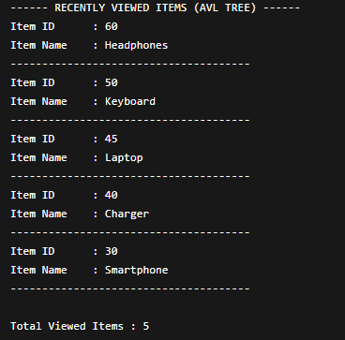

The AVL Tree provided fast insertion and retrieval for recently viewed items.
The most recently accessed 5 items returned were:
Headphones (ID: 60), Keyboard (ID: 50), Laptop (ID: 45), Charger (ID: 40), Smartphone (ID: 30)
Time Complexity:
• Insert/Delete: O(log n)
• Retrieval (Top-K Recent): O(k + log n)

GitHub Link: https://github.com/sribhargavivaddavalli-svg/DSA_CASESTUDIES

